TEST 1: Wind farm operation permitted / forbidden test 3
1. Purpose of the test 3
2. Time of testing 3
3. Success Criteria 3
4. Test procedure 3
5. Test conditions 3
6. Test results 3
TEST 2: Emergency power curtailment test 4
1. Purpose of the test 4
2. Time of testing 4
3. Success criteria 4
4. Test procedure 4
5. Test conditions 4
6. Test results 4
TEST 3: Active power setpoint control/Secondary Control Test 7
1. Purpose of the test 7
2. Time of testing 7
3. Success criteria 7
4. Test procedure 7
5. Test conditions 7
6. Test results 7
TEST 4: Adjustment of reactive power at U=const. test 9
1. Purpose of the test 9
2. Time of testing 9
3. Success criteria 9
4. Test procedure 9
5. Test conditions 9
6. Test results 9
TEST 5: Measuring of P/Q diagram of wind farm at point of common coupling 11
1. Purpose of the test 11
2. Time of testing 11
3. Success criteria 11
4. Test procedure 11
5. Test conditions 11
6. Test results 12
TEST 6: Adjustment of reactive performance Q=const. test 13
1. Purpose of the test 13
2. Time of testing 13
3. Success criteria 13
4. Test procedure 13
5. Test conditions 13
6. Test results 13
TEST 7: Short interruption of grid connection test 14
1. Purpose of the test 14
2. Time of testing 14
3. Success criteria 14
4. Test procedure 14
5. Test conditions 14
6. Test results 14
TEST 8: Short interruption of grid connection test without the central operation system 15
1. Purpose of the test 15
2. Time of testing 15
3. Success criteria 15
4. Test procedure 15
5. Test conditions 15
6. Test results 15
TEST 9: Operation without central control system 24 h 16
1. Purpose of the test 16
2. Time of testing 16
3. Success criteria 16
4. Test procedure 16
5. Test conditions 16
6. Test results 16
TEST 10: Primary regulation 17
1. Purpose of the test 17
2. Time of testing 17
3. Success criteria 17
4. Test procedure 18
5. Test conditions 18
6. Test results 19

TEST 1: Wind farm operation permitted / forbidden test

Purpose of the test
The test confirms the ability to stop the WF after the SO Elering has set the signal: “wind park operation” to “OFF” and starts production again after the SO Elering has set the signal: “wind park operation” to “ON”.

Time of testing
Test was performed on XXX XXXX-XX-XX between XX:XX h and XX:XXh (GPS time).

Success Criteria
Wind farm stops it’s production as quickly as possible and returns to operation after permission is granted by TSO.

Test procedure
To be explained what was done.

Test conditions
XX of the installed XX WECs were in operation before and after switching the wind park operation to “OFF”. At the beginning of the test, the active power supply of the WF was approximately XX MW which is 89.8% of MEC.

Test results
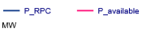
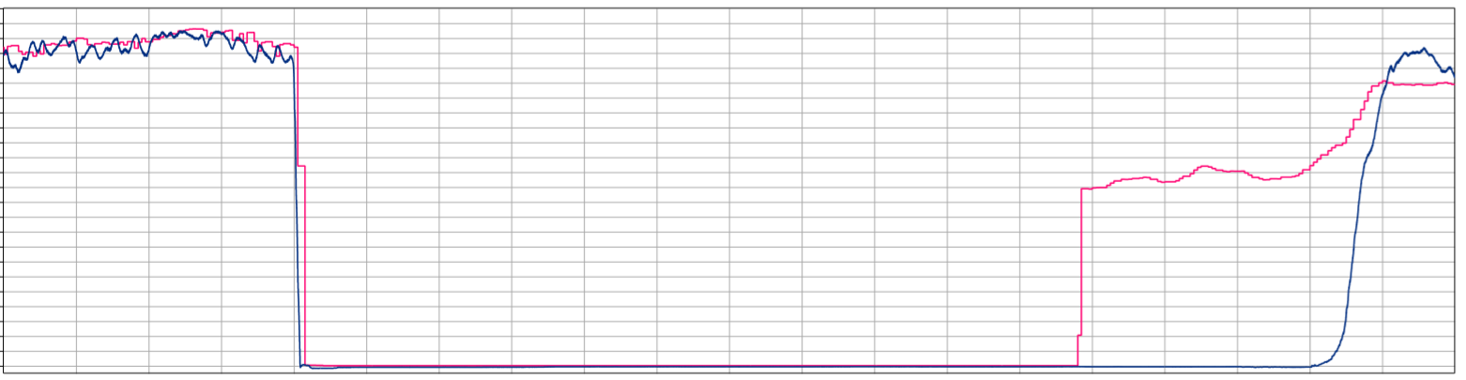
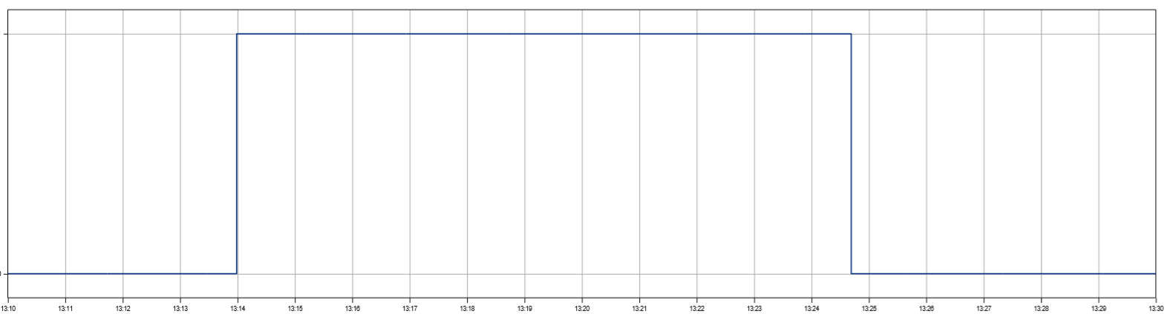
Measured signals: P_RPC, P_available and WP_operation_OFF of: “Operation of wind park permitted / forbidden test”

TEST 2: Emergency power curtailment test

Purpose of the test
The purpose of this test is to prove, that the WF is able to limit its active power in emergency situations to various levels of remaining grid connected turbines.

Time of testing
This test was conducted on the XXth XXXX XXXX between XX:XX and the XXth XXXX XX:XX.

Success criteria
Wind farm output power is curtailed according to signal sent by Elering, whether 20, 40, 60 or 80% of active power levels.

Test procedure
To be explained what was done.

Test conditions
For the duration of the test all XX WECs were in operation and generated up to XX MW which is equivalent to 100% of MEC.

Test results


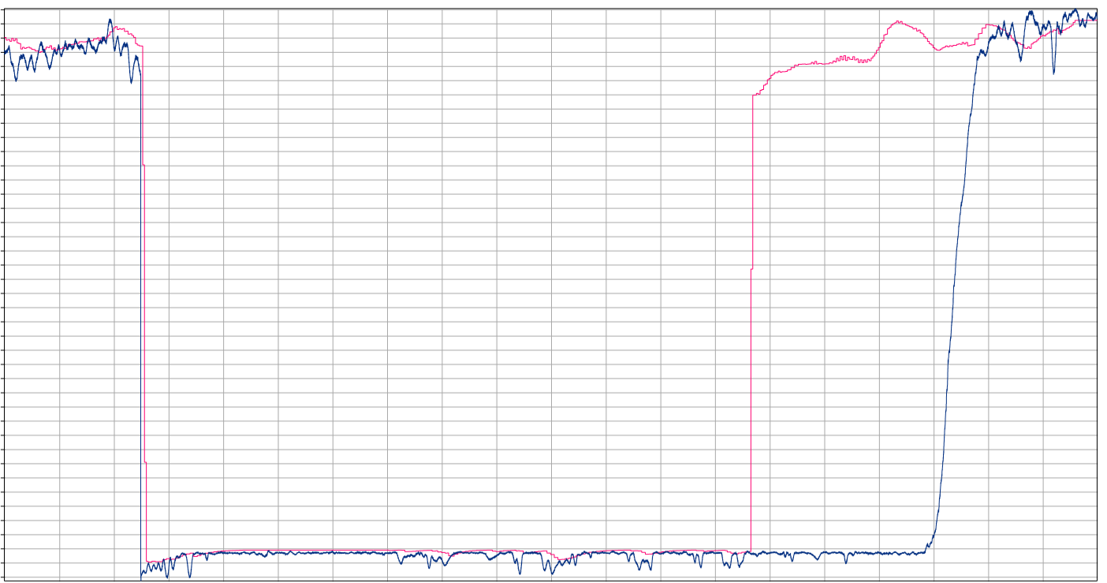
Decreasing the performance in emergency situations – 20%

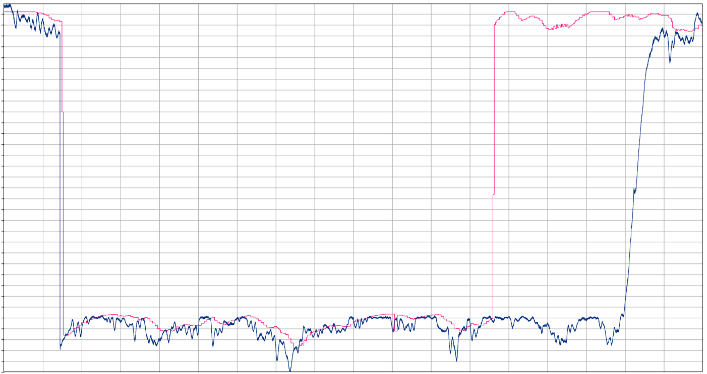
Decreasing the performance in emergency situations – 40%

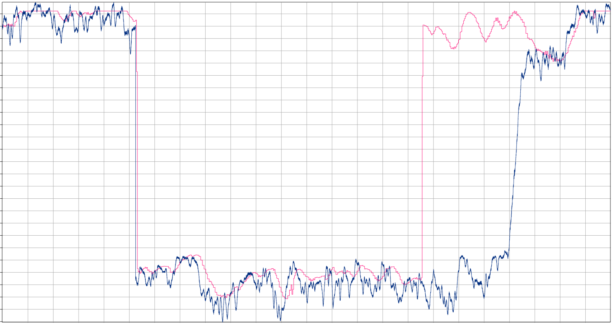


Decreasing the performance in emergency situations – 60%

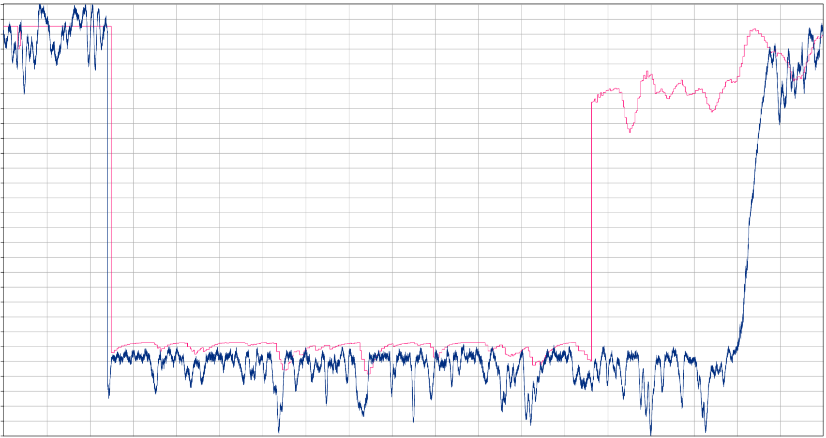

Decreasing the performance in emergency situations – 80%

TEST 3: Active power setpoint control/Secondary Control Test

Purpose of the test
The purpose of this test is show the behavior of the wind farm during secondary regulation.

Time of testing
This test was conducted on the XXth of XXXX XXXX between XX:XX and XX:XX.

Success criteria
Article 15. Paragraph 2. Difference between Power Generating Modules output power active power setpoint shall be less than +/-5% of nominal active power, but not more than -/+ 5MW, depending whichever is smaller.
Article 15. Paragraph 2. Point 4. The active power output of the power park module shall be able to change at a rate of at least 8% of the rated power per minute, when weather conditions allow. At this speed, the active power shall be adjustable within a range of 30 per cent between 20 and 100 per cent of the rated power of the PPM.

Test procedure
To be explained what was done.

Test conditions
For the duration of the test all XX WECs were in operation and generated up to XX MW which is equivalent to 100% of MEC

Test results
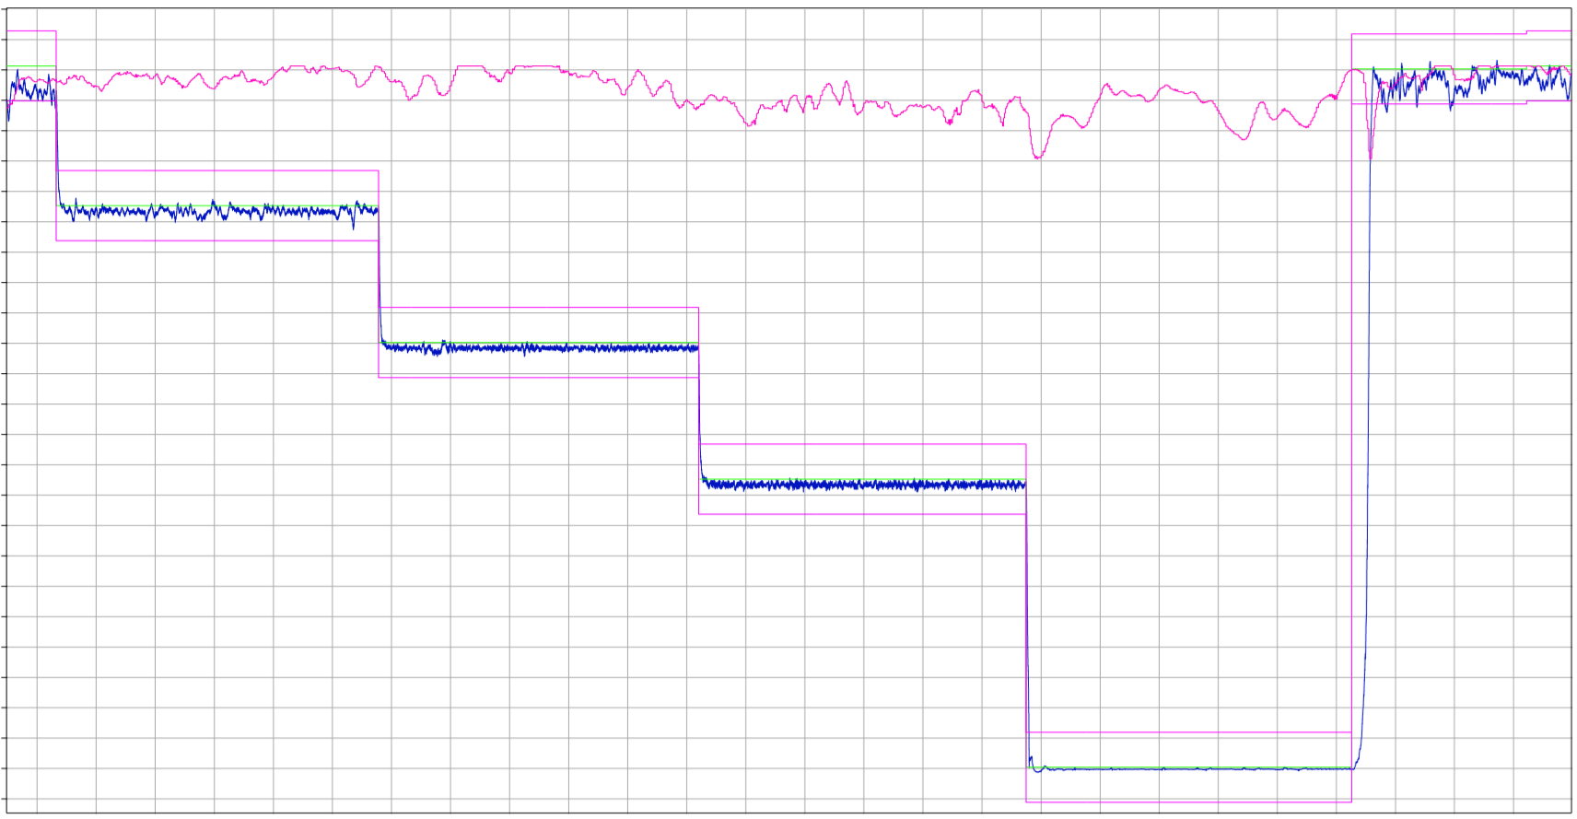


Smooth adjustment of active capacity secondary adjustmen
Graphs marked with red to be zoomed in and added to main graph or table to be added with times of setpoint received and setpoint reached.
Time | Active Power Setpoint | Active power reached | Time when setpoint was reached | Ramp rate | Ramp Rate
15:35:11 | X MW | X,X MW | 15:38:12 | X MW/min | 9% Pn/min
… | … | … | … | … | …

TEST 4: Adjustment of reactive power at U=const. test

Purpose of the test
The purpose of this test is to prove the functionality of the voltage controller with different voltage setpoints.

Time of testing
This test was conducted between the XXth of XXXX XXXX XX:XX and the XXth of XXXX XXXX XX:XX.

Success criteria
Article 21.3.d.i - the power park module shall be capable of providing reactive power automatically by either voltage control mode, reactive power control mode or power factor control mode;
Article 21.3.d.ii - for the purposes of voltage control mode, the power park module shall be capable of contributing to voltage control at the connection point by provision of reactive power exchange with the network with a setpoint voltage covering 0,95 to 1,05 pu in steps no greater than 0,01 pu, with a slope having a range of at least 2 to 7 % in steps no greater than 0,5 %. The reactive power output shall be zero when the grid voltage value at the connection point equals the voltage setpoint;
Article 21.3.d.iii - the setpoint may be operated with or without a deadband selectable in a range from zero to ± 5 % of reference 1 pu network voltage in steps no greater than 0,5 %;
Article 21.3.d.iv - following a step change in voltage, the power park module shall be capable of achieving 90 % of the change in reactive power output within 5 seconds, and must settle at the value in 60 seconds, with a steady-state reactive tolerance no greater than 5 % of the maximum reactive power.

Test procedure
To be explained what was done.

Test conditions
At the beginning of the test: “Adjustment of reactive power at U=const. regime”, XX of the installed XX WECs were in operation. At the second day of the test (XXXX-XX-XX) between XX:XX h and XX:XXh (GPS time) the availability of the WECs was temporary reduced up to XX WECs.The active power supply of the WF was approximately XX MW which is 50.3% of MEC at the beginning of the test.

Test results
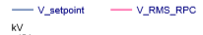
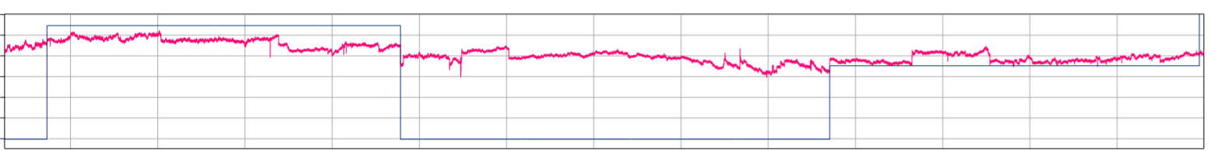

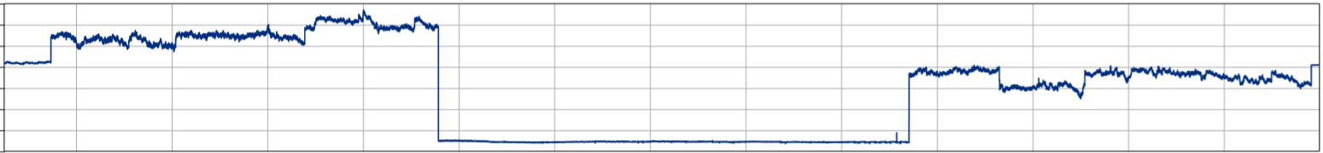
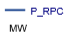
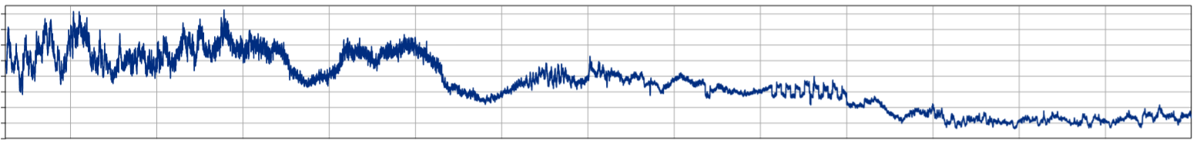
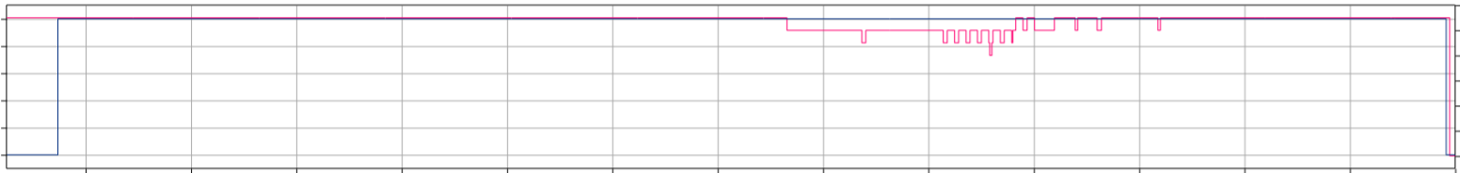
Measured signals: V_RMS_RPC, V_setpoint, Q_RPC, P_RPC, Q_contr_U_const and WEC_available of: “Adjustment of reactive power at U=const. regime.” Test

TEST 5: Measuring of P/Q diagram of wind farm at point of common coupling

Purpose of the test
The purpose of this test is to demonstrate the reactive power performance of different active power levels.

Time of testing
This test was conducted on the XXth of XXXX XXXX between XX:XX and XX:XX.

Success criteria
Article 21. Paragraph 3. Point c. is fulfilled.
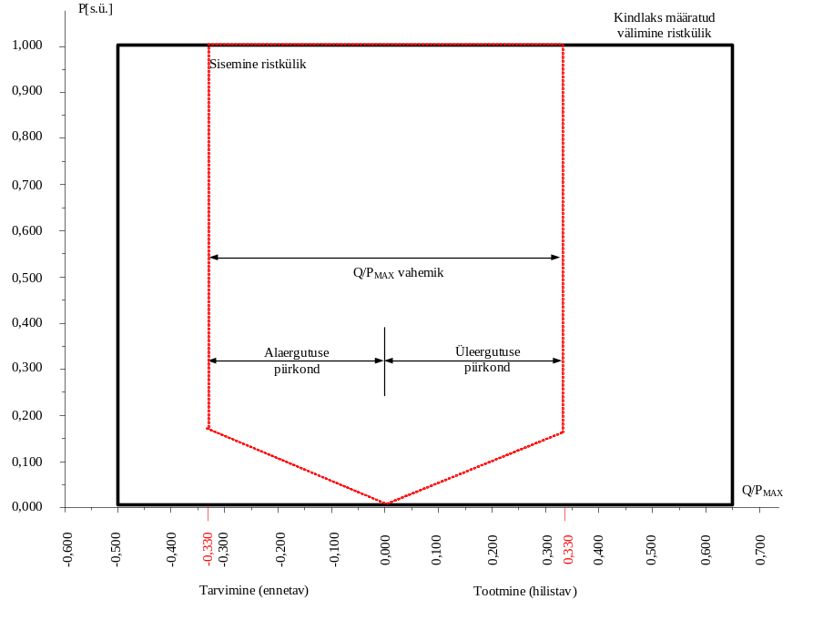
The diagram represents boundaries of a P-Q/P_{max}-profile at the connection point by the active power, expressed by the ratio of its actual value and the maximum capacity pu, against the ratio of the reactive power (Q) and the maximum capacity (P_{max}).

Test procedure
To be explained what was done.

Test conditions
For the duration of this test XX of XX WECs were in operation and generated around XX MW before beginning of the test.

Test results
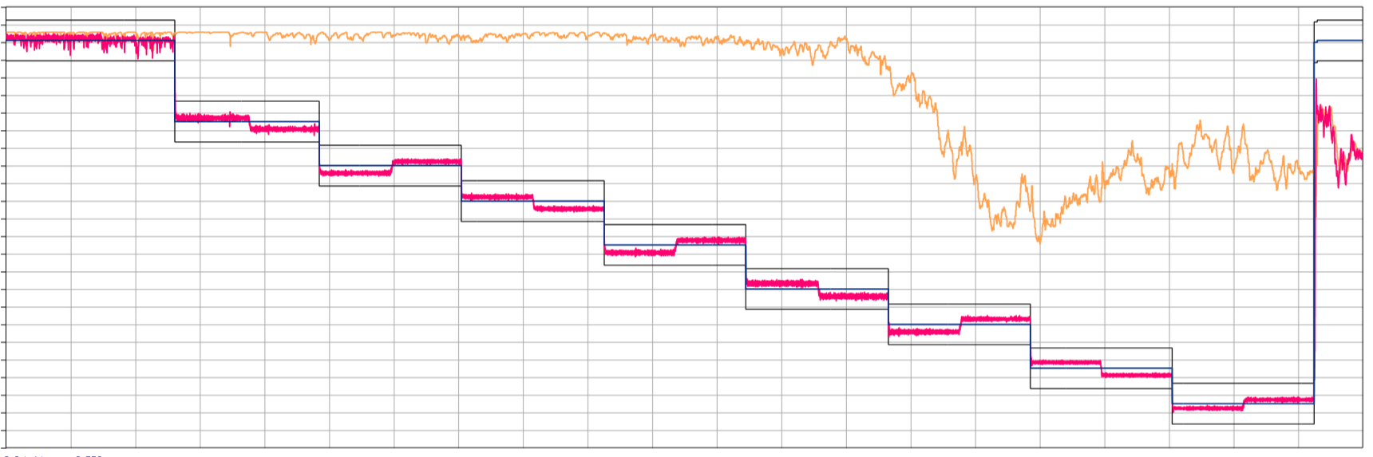
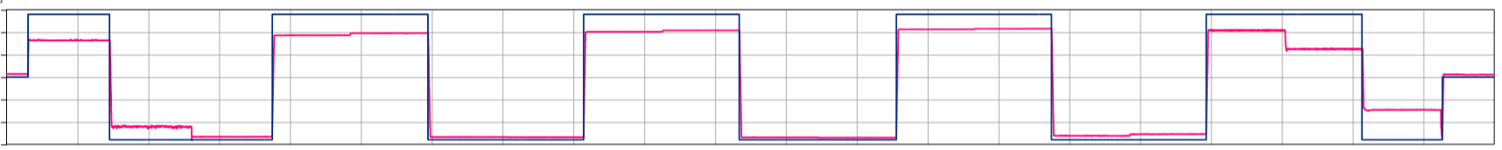
Measured signals: P_setpoint, P_RPC, P_available, P_tolerance_pos, P_tolerance_neg, Q_setpoint, Q_RPC and V_RMS_RPC, of: “Measuring at P/Q parameter of wind turbine at subscription point” test
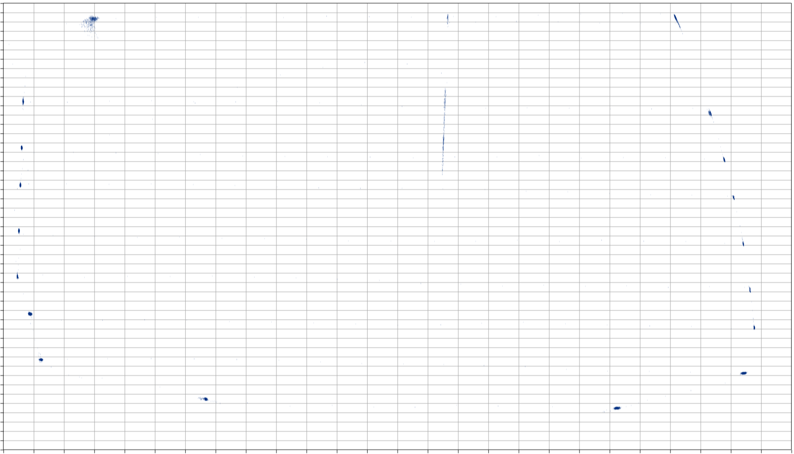
Resultant P/Q-diagram of: “Measuring at P/Q parameter of wind turbine at connection point” test

TEST 6: Adjustment of reactive performance Q=const. test

Purpose of the test
The purpose of this test is to verify the performance and accuracy of the reactive power controller with different reactive power set points.

Time of testing
Test was performed on XXXX XXXX-XX-XX between XX:XX h and XX:XX h (GPS time).

Success criteria
Article 21. Paragraph 3. Point d. (v). - for the purpose of reactive power control mode, the power park module shall be capable of setting the reactive power setpoint anywhere in the reactive power range, specified by point (a) of Article 20(2) and by points (a) and (b) of Article 21(3), with setting steps no greater than 5 MVAr or 5 % (whichever is smaller) of full reactive power, controlling the reactive power at the connection point to an accuracy within plus or minus 5 MVAr or plus or minus 5 % (whichever is smaller) of the full reactive power;

Test procedure
To be explained what was done.

Test conditions
XX of the installed XX WECs were in operation during the test: “Adjustment of reactive performance Q=const.”. At the beginning of the test, the active power supply of the WF was approximately XX MW which is 26.4 % of MEC.

Test results

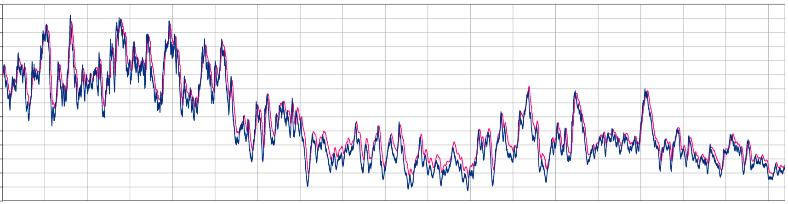
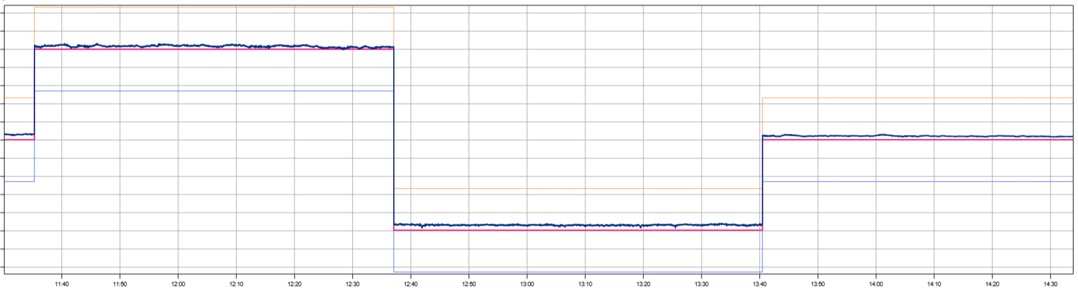
Measured signals: P_RPC, P_available, Q_RPC, Q_Setpoint, Q_tolerance_p and Q_tolerance_n of: “Adjustment of reactive performance Q=const. test”

TEST 7: Short interruption of grid connection test

Purpose of the test
The purpose of this test is to proof that the wind turbines start production automatically, after an interruption of the grid connection.

Time of testing
This test was conducted on the XXth of XXXX XXXX between XX:XX and XX:XX.

Success criteria

Test procedure
To be explained what was done.

Test conditions
For the duration of this test XX of XX WECs were in operation and generated around XX MW before beginning of the test.

Test results


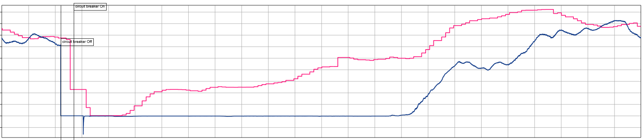
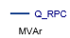
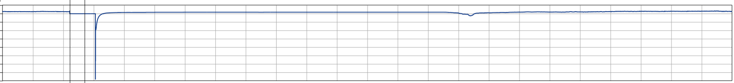
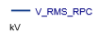
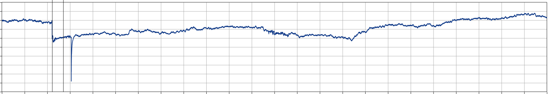
Measured signals: P_RPC, P_available, Q_RPC and V_RMS_RPC of: “Short interruption of grid connection test”

TEST 8: Short interruption of grid connection test without the central operation system

Purpose of the test
The purpose of this test is to proof, that the wind turbines start production automatically, after an interruption of the grid connection. In deviation of the previous test, the central control computer was switched off.

Time of testing
This test was conducted on the XXth of XXXX XXXX between XX:XX and XX:XX.

Success criteria

Test procedure
To be explained what was done.

Test conditions
For the duration of this test XX of XX WECs were in operation and generated around XX MW before beginning of the test.

Test results

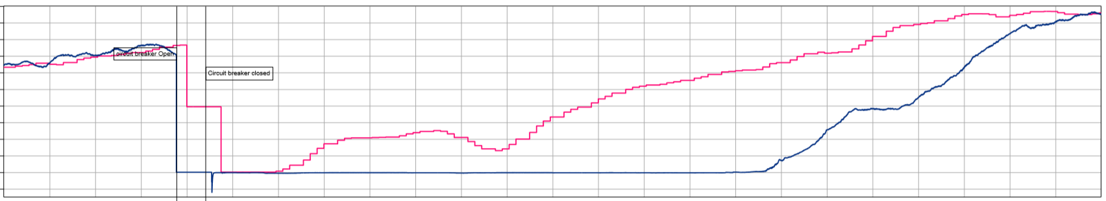
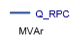
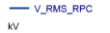
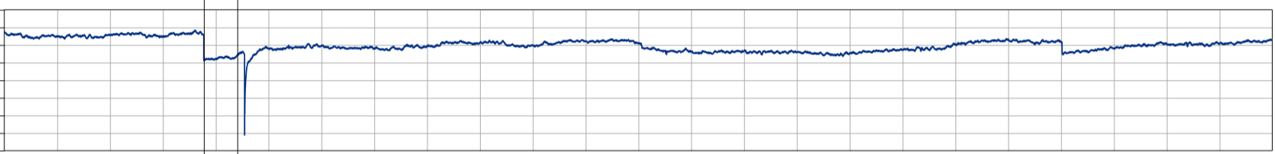

TEST 9: Operation without central control system 24 h

Purpose of the test
The purpose of this test is to show the behaviour of the wind farm without central control system during 24 h.

Time of testing
This test was conducted between the XXth of XXXX XXXX XX:XX and the XXth of XXXX XXXX XX:XX

Success criteria
The power park module shall operate without disturbances while central control system is disabled. Reactive power should be close to zero while operating.

Test procedure
To be explained what was done.

Test conditions
For the duration of this test XX of XX WECs were in operation and generated between XX MW and XX MW with an average generation of XX MW.

Test results

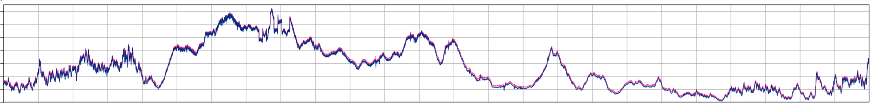
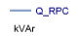
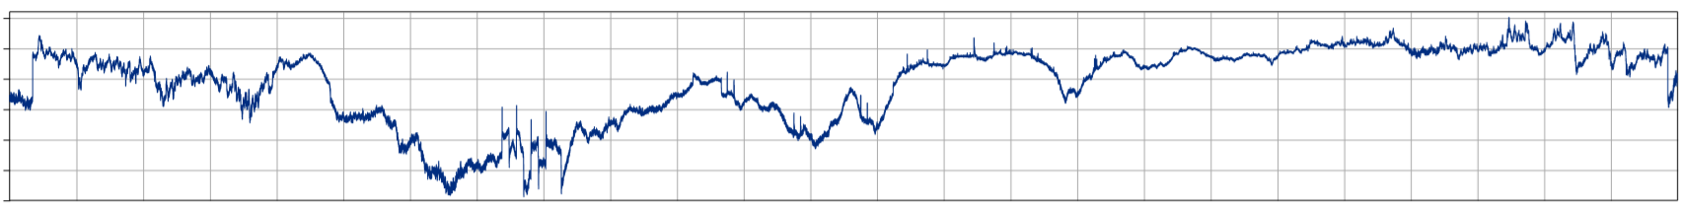
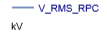
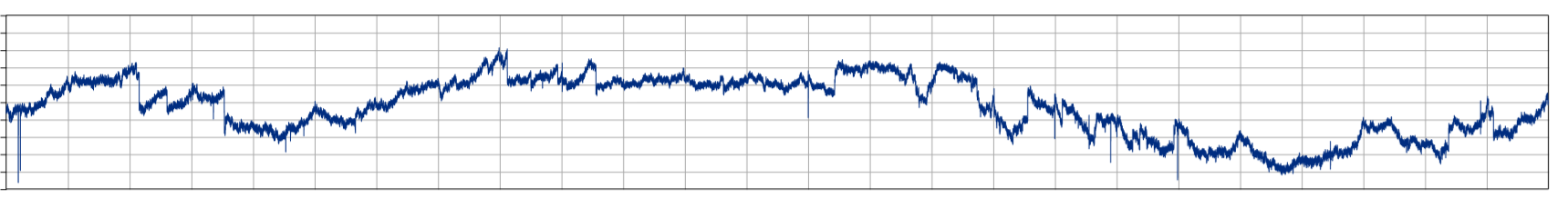
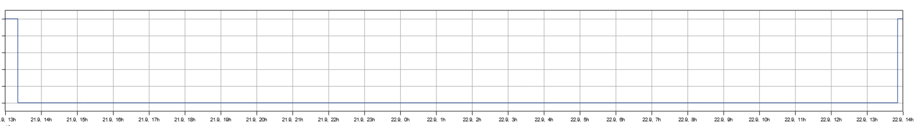
Measured signals: P_RPC, P_available, Q_RPC, V_RMS_RPC and FCU_operation of: “Operation without central control system 24 h” test

TEST 10: Primary regulation

Purpose of the test
The purpose of this test is to confirm the behaviour of the wind farm in case of frequency changes.

Time of testing
This test was conducted on the XXth of XXXX XXXX between XX:XX and XX:XX.

Success criteria
Article 15. Paragraph 2. Point c. the power-generating module shall be capable of activating the provision of active power frequency response at a frequency threshold and with a droop specified by the relevant TSO in coordination with the TSOs of the same synchronous area as follows:
- the frequency limit set by the transmission system operator shall be 49.8 Hz;
- the statistics provided by the transmission system operator must be 5%.
Article 13. Paragraph 2. Point a. The power-generating module shall trigger the active power frequency response with a frequency of 50.2 Hz and droop settings of 5%.
Article 15. Paragrapg 2. Point d. The power-generating module shall be capable of providing active power frequency response in accordance with the parameters specified by each relevant TSO within the ranges shown in Table 4. In specifying those parameters, the relevant TSO shall take account of the following facts:
— | in case of overfrequency, the active power frequency response is limited by the minimum regulating level,

— | in case of underfrequency, the active power frequency response is limited by maximum capacity,

— | the actual delivery of active power frequency response depends on the operating and ambient conditions of the power-generating module when this response is triggered, in particular limitations on operation near maximum capacity at low frequencies according to paragraphs 4 and 5 of Article 13 and available primary energy sources;
Table 4
Parameters for active power frequency response in FSM (explanation for Figure 5)
Parameters |  | Ranges
Active power range related to maximum capacity 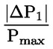 |  | 10 %
Frequency response insensitivity | 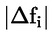 | 10 mHz
Frequency response insensitivity | 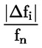 | 0,02 %
Frequency response deadband |  | 0-500 mHz
Droop s ₁ |  | 2-12 %

Test procedure
To be explained what was done.

Test conditions
XX of the installed XX WECs were in operation during the tests: “Primary regulation”. At the beginning of each test, the available active power of the WF was approximately XX MW.

Test results
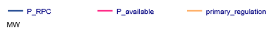
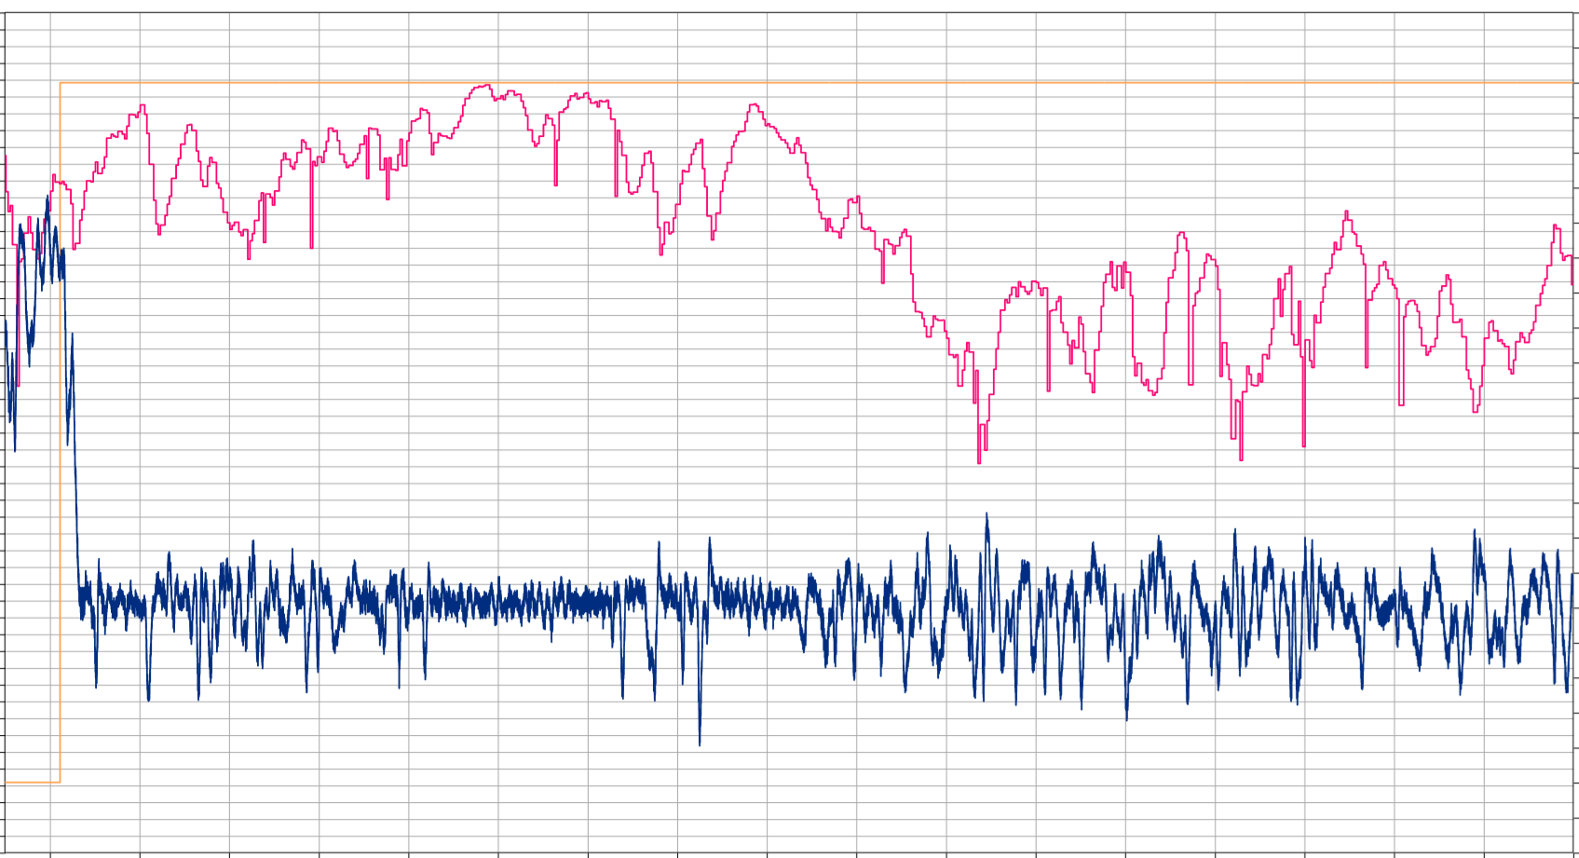
Performance of the P(f)-controller in the “normal mode” (active power reserve capacity ≥ 10 % of MEC)

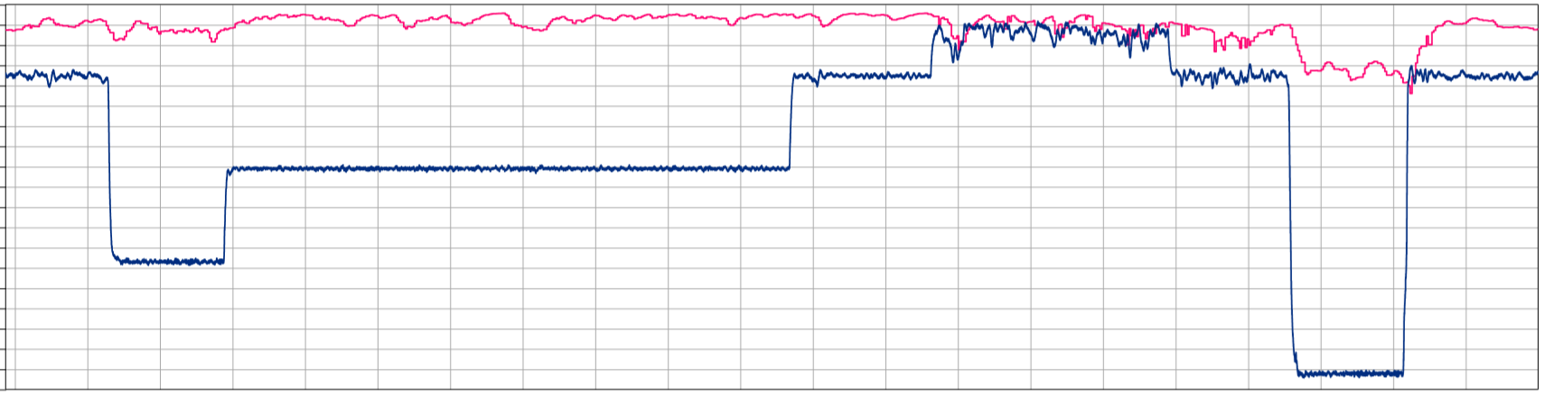
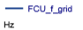
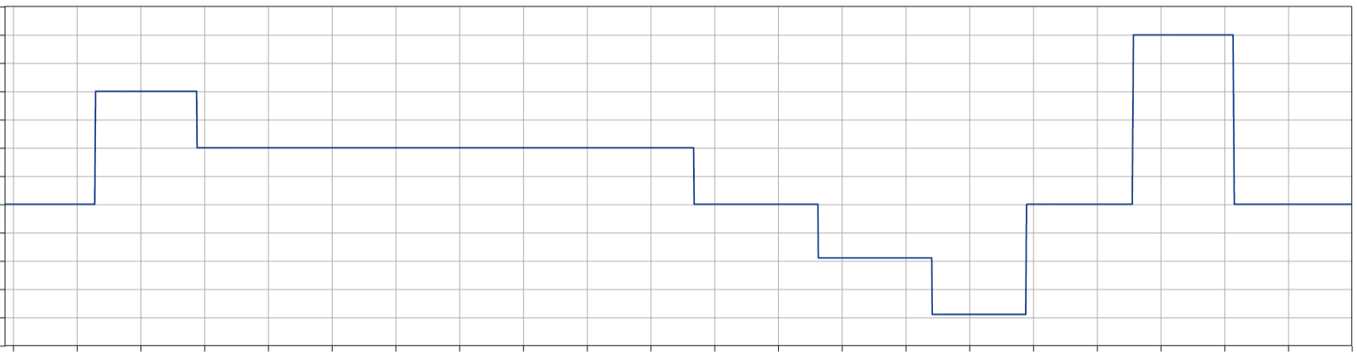
Primary adjustment control test with a deadband of 10 mHz and a slope of 2 %
Graphs marked with red to be zoomed in and added to main graph or table to be added with times of frequency injected and primary regulation reached.
Start time of regulation | Active Power level according to droop | Active power reached | Time when setpoint was reached | Ramp rate | Time for regulation
17:55:11 | X MW | X,X MW | 15:38:12 | X MW/min | X s
… | … | … | … | … | …


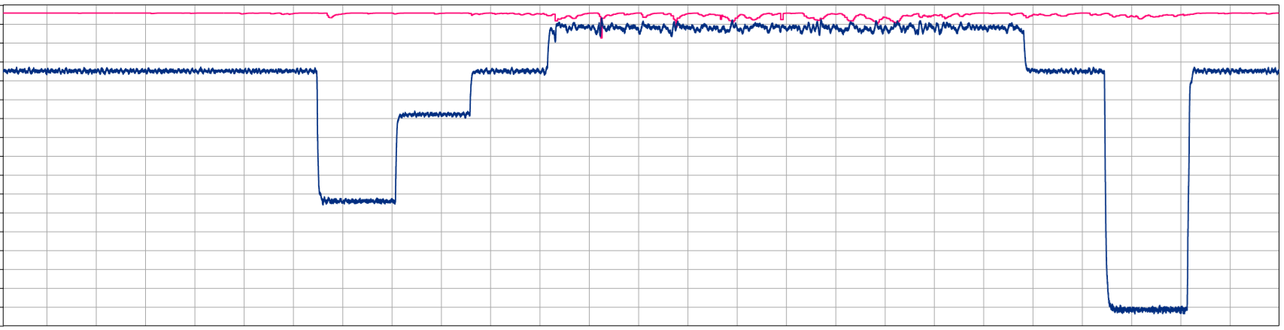
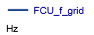
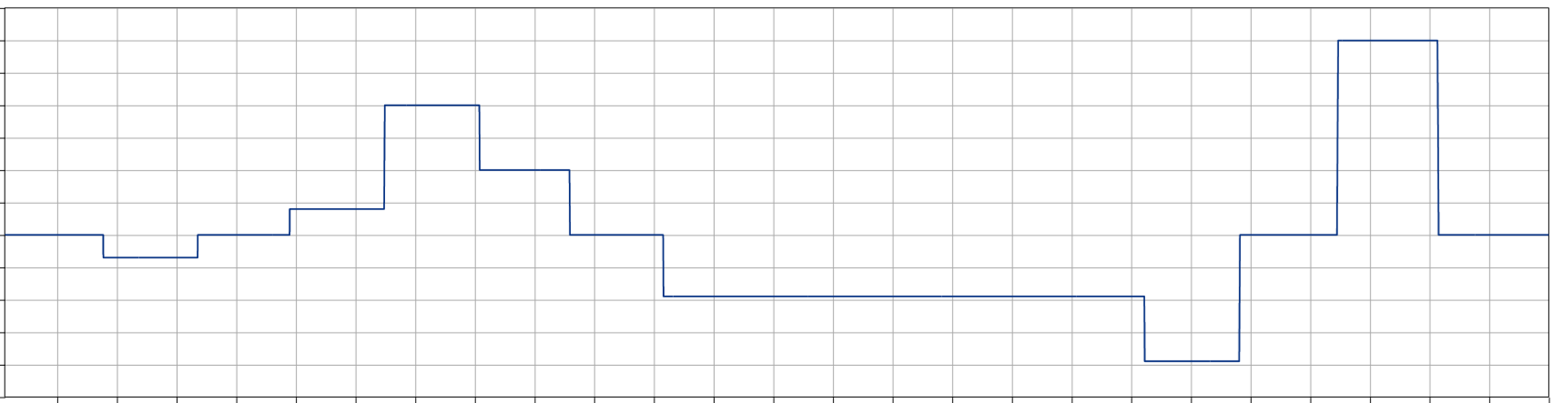
Primary adjustment control test with a deadband of 100 mHz and a slope of 2 %

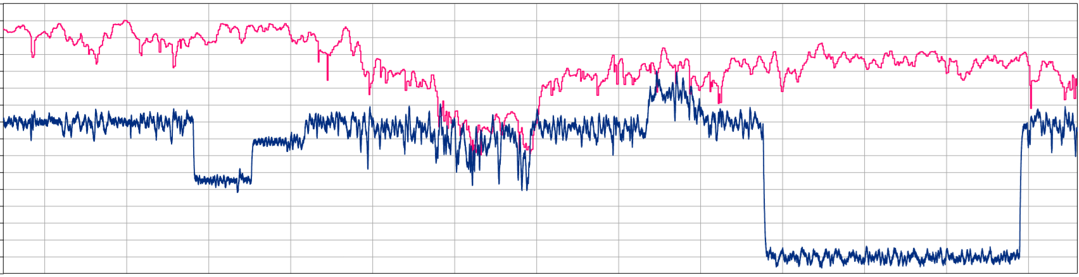

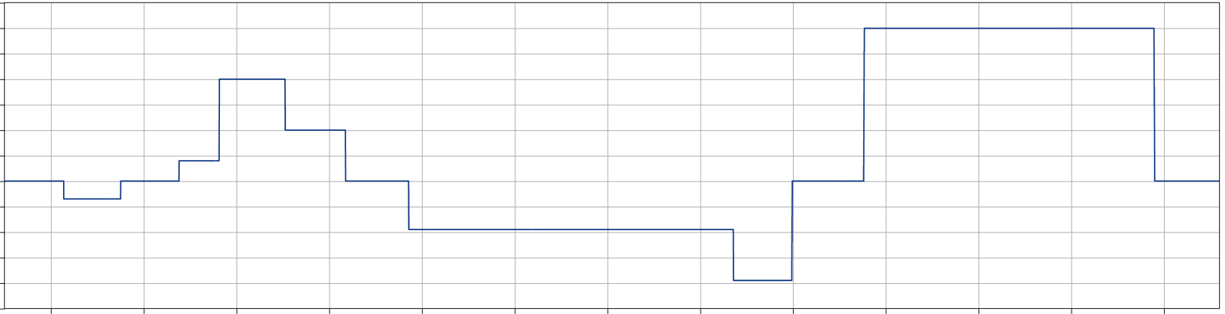
Primary adjustment control test with a deadband of 100 mHz and a slope of 8 %

